Problem Statement: Stepwise Execution Analysis of Greedy Algorithms

Fractional Knapsack
Theory:

- Input: read n (items) and capacity.

- Read arrays: read value[0..n-1] and weight[0..n-1].

- Prepare ratios & indices: for each item i compute ratio[i] = value[i]/weight[i] and idx[i] = i.

- Sort items: sort idx by ratio[idx[k]] in descending order.

- Initialize: profit = 0.0, rem = capacity.

- Greedy pick: iterate k = 0..n-1 while rem > 0:

- let id = idx[k].
- if weight[id] <= rem: take whole item → rem -= weight[id], profit += value[id].
- else: take fraction f = rem / weight[id] → profit += f * value[id], set rem = 0.

- Output: report selected items (and fractions) and profit (maximum profit).

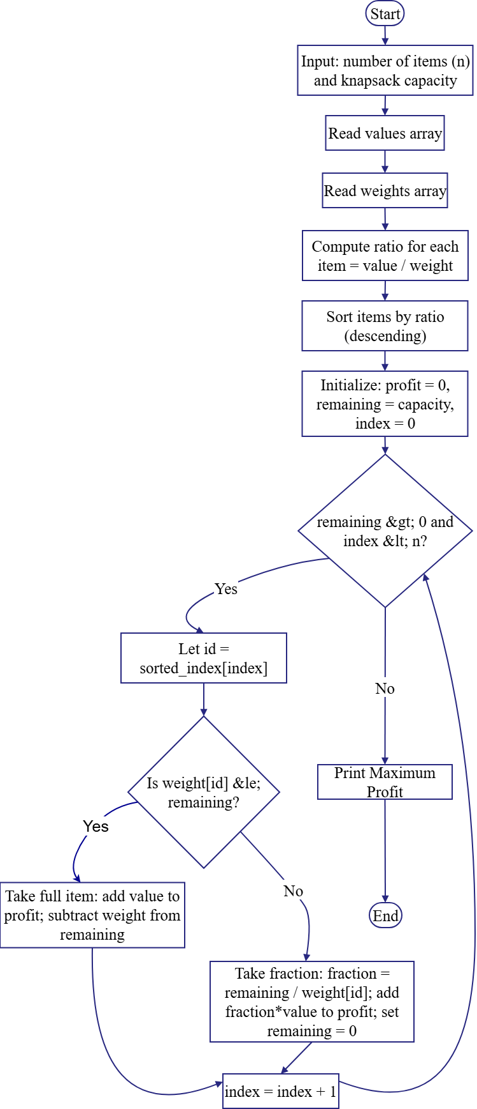
Flow Chart:
Code:
- #include <bits/stdc++.h>
- using namespace std;

- int main() {
- int n, capacity;
- cout << "Enter number of items: ";
- cin >> n;
- cout << "Enter knapsack capacity: ";
- cin >> capacity;

- vector<int> value(n), weight(n);
- vector<double> ratio(n);
- vector<int> idx(n);
- for (int i = 0; i < n; i++)
- idx[i] = i;

- cout << "Enter values: ";
- for (int i = 0; i < n; i++)
- cin >> value[i];

- cout << "Enter weights: ";
- for (int i = 0; i < n; i++)
- cin >> weight[i];

- for (int i = 0; i < n; i++) {
- ratio[i] = (double)value[i] / weight[i];
- }

- sort(idx.begin(), idx.end(), [&](int a, int b) {
- return ratio[a] > ratio[b];
- });

- double profit = 0;
- int rem = capacity;

- cout << "\nSelection Order (Highest ratio first):\n";
- for (int i = 0; i < n && rem > 0; i++) {
- int id = idx[i];
- if (weight[id] <= rem) {
- rem -= weight[id];
- profit += value[id];
- cout << "Item " << (id + 1) << " (full): +" << value[id] << " (w=" << weight[id] << ")\n";
- }
- else {
- double frac = (double)rem / weight[id];
- profit += frac * value[id];
- cout << "Item " << (id + 1) << " (fraction " << rem << "/" << weight[id]
- << "): +" << (int)(frac * value[id]) << "\n";
- rem = 0;
- }
- }

- cout << "\nMaximum Profit = " << (int)profit << endl;
- return 0;
- }
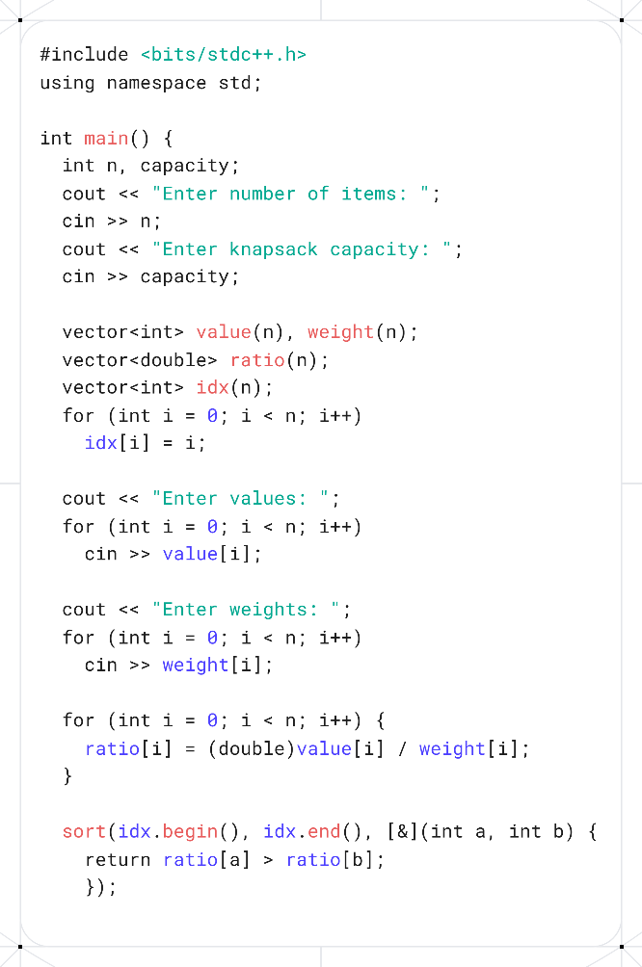
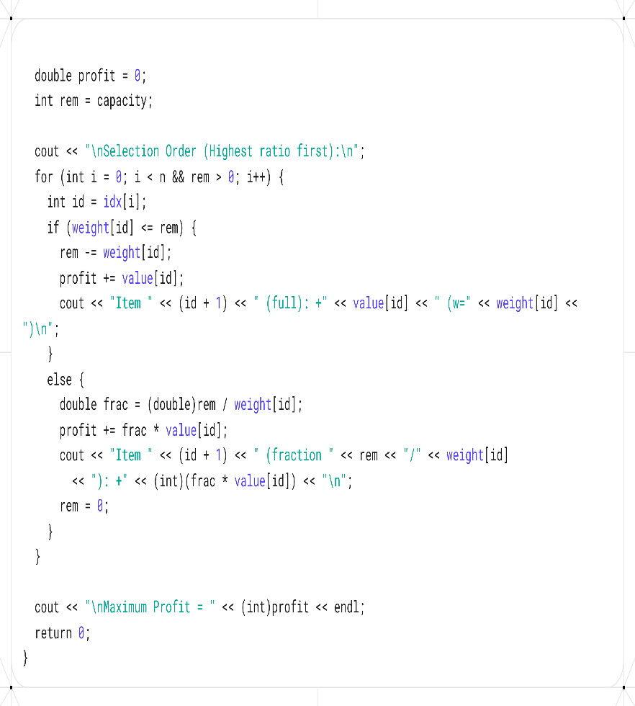
Screenshots:

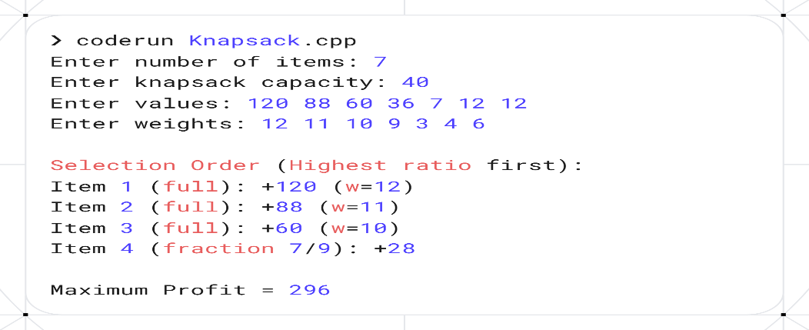

Analysis:
Input:
Number of items n = 7
Knapsack capacity C = 40
Values = [120, 88, 60, 36, 7, 12, 12]
Weights = [12, 11, 10, 9, 3, 4, 6]

Stepwise Execution (Item Selection)
Step 1:
- Select Item 1 → weight = 12 ≤ 40 → take full.
- Profit = 120, Remaining capacity = 28.
Step 2:
- Select Item 2 → weight = 11 ≤ 28 → take full.
- Profit = 120 + 88 = 208, Remaining capacity = 17.

Step 3:
- Select Item 3 → weight = 10 ≤ 17 → take full.
- Profit = 208 + 60 = 268, Remaining capacity = 7.
Step 4:
- Select Item 4 → weight = 9 > 7 → take fraction = 7/9.
- Profit += (7/9) × 36 = 28 (approx).
- Profit = 296, Remaining capacity = 0.

Final Output:

Selection Order:
- Item 1 (full) → +120
- Item 2 (full) → +88
- Item 3 (full) → +60
- Item 4 (fraction 7/9) → +28

Maximum Profit = 296
Remaining Capacity = 0

Complexity Analysis:
- Time Complexity:
    - Calculating ratios → O(n)
    - Sorting items by ratio → O(n log n)
    - Selecting items (greedy filling) → O(n)
    - Total: O(n log n) (sorting dominates)
- Space Complexity:
    - Uses additional arrays for value, weight, ratio, and index → O(n)
    - Total: O(n)
Overall Efficiency:
The algorithm is efficient for fractional knapsack problems — it achieves an optimal solution using a greedy approach in O(n log n) time with linear space usage.

Activity Selection Problems.
Theory:

- Start
- Input total number of activities n.
- Read three arrays:
- activityNum[1..n] → activity numbers
- start[1..n] → start times
- finish[1..n] → finish times
- Sort all activities in ascending order of finish times.
- Initialize:
- selectedActivity, selectedStart, selectedFinish as empty lists
- Select the first activity (earliest finish time):
    - add it to selectedActivity, selectedStart, and selectedFinish
    - set lastFinish = finish[0]
- Repeat for each remaining activity i = 1 to n-1:
- If start[i] ≥ lastFinish → select the activity
  - add it to selected lists
  - update lastFinish = finish[i]
- Output the selected activities, their start and finish times, and the total number of selected activities.
- End

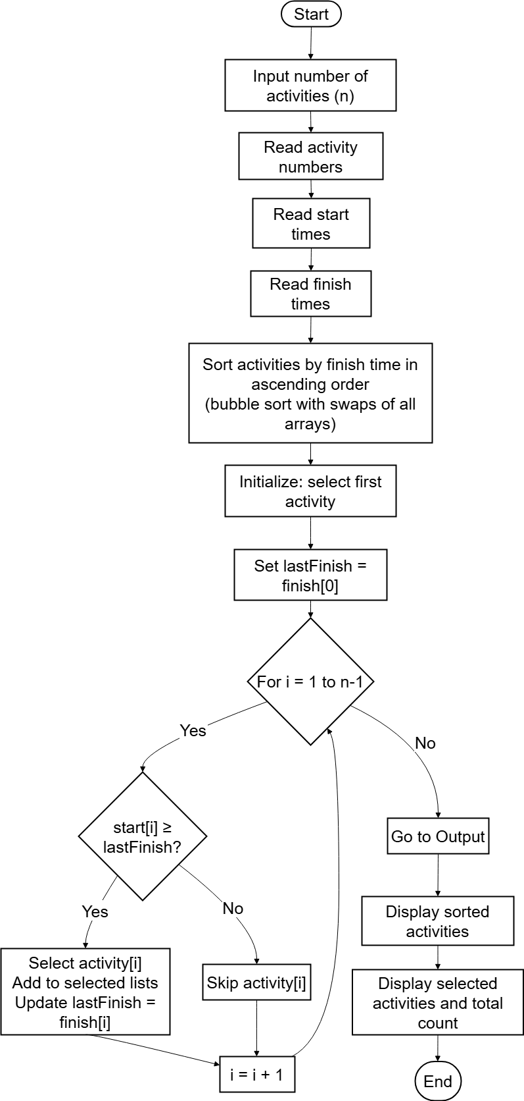
Code:
- #include <bits/stdc++.h>
- using namespace std;

- int main() {
- int n;
- cout << "Enter the number of activities: ";
- cin >> n;

- vector<int> activityNum(n);
- vector<int> start(n);
- vector<int> finish(n);

- cout << "\nEnter activity numbers: ";
- for (int i = 0; i < n; i++) {
- cin >> activityNum[i];
- }

- cout << "Enter start times: ";
- for (int i = 0; i < n; i++) {
- cin >> start[i];
- }

- cout << "Enter finish times: ";
- for (int i = 0; i < n; i++) {
- cin >> finish[i];
- }

- for (int i = 0; i < n - 1; i++) {
- for (int j = 0; j < n - i - 1; j++) {
- if (finish[j] > finish[j + 1]) {
- swap(finish[j], finish[j + 1]);
- swap(start[j], start[j + 1]);
- swap(activityNum[j], activityNum[j + 1]);
- }
- }
- }

- cout << "\n--- After sorting by finish time in ascending order ---\n";
- cout << "\nActivity\t";
- for (int i = 0; i < n; i++) {
- cout << activityNum[i] << "\t";
- }

- cout << "\nStart\t\t";
- for (int i = 0; i < n; i++) {
- cout << start[i] << "\t";
- }

- cout << "\nFinish\t\t";
- for (int i = 0; i < n; i++) {
- cout << finish[i] << "\t";
- }
- cout << endl;
- vector<int> selectedActivity;
- vector<int> selectedStart;
- vector<int> selectedFinish;

- selectedActivity.push_back(activityNum[0]);
- selectedStart.push_back(start[0]);
- selectedFinish.push_back(finish[0]);
- int lastFinish = finish[0];

- for (int i = 1; i < n; i++) {
- if (start[i] >= lastFinish) {
- selectedActivity.push_back(activityNum[i]);
- selectedStart.push_back(start[i]);
- selectedFinish.push_back(finish[i]);
- lastFinish = finish[i];
- }
- }

- cout << "\n--- Selected Activities (Maximum Set) ---\n";
- cout << "Number of activities selected: ";
- cout << selectedActivity.size() << "\n\n";
- cout << "Activity\tStart\tFinish\n";
- for (int i = 0; i < selectedActivity.size(); i++) {
- cout << selectedActivity[i] << "\t\t";
- cout << selectedStart[i] << "\t" << selectedFinish[i] << endl;
- }

- return 0;
- }
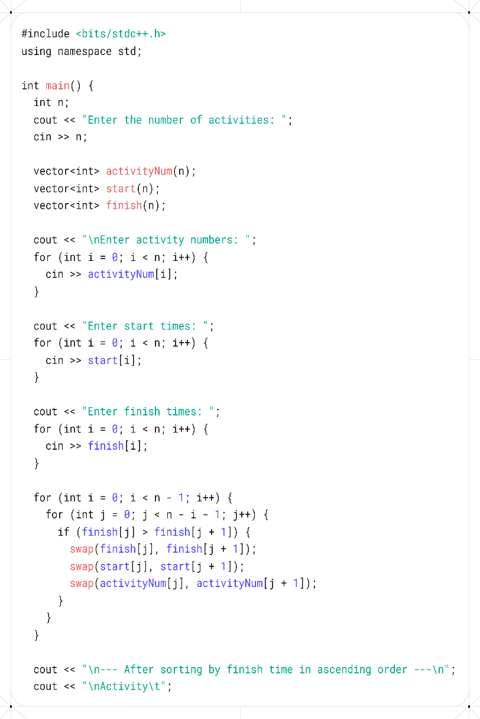
Screenshots:
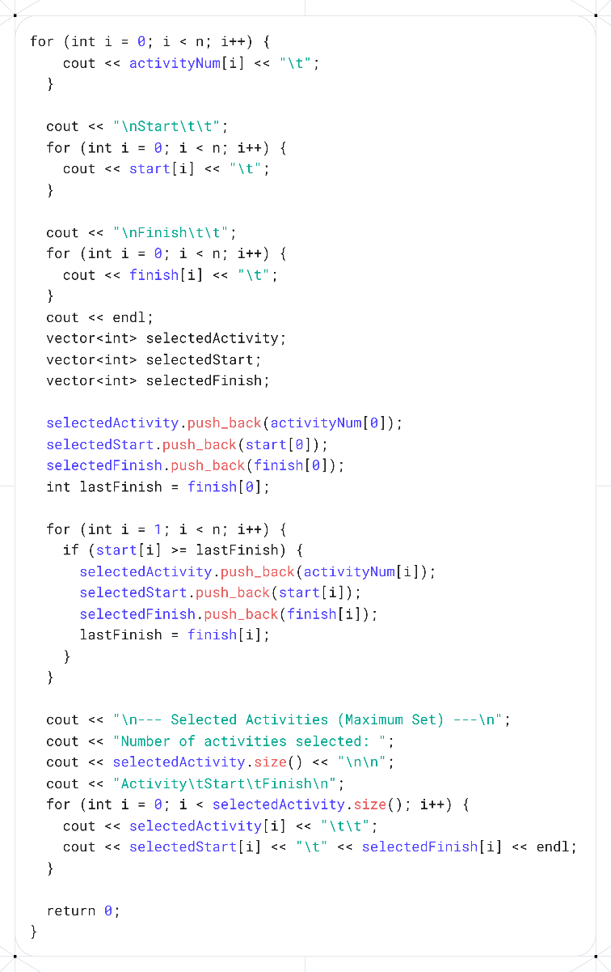

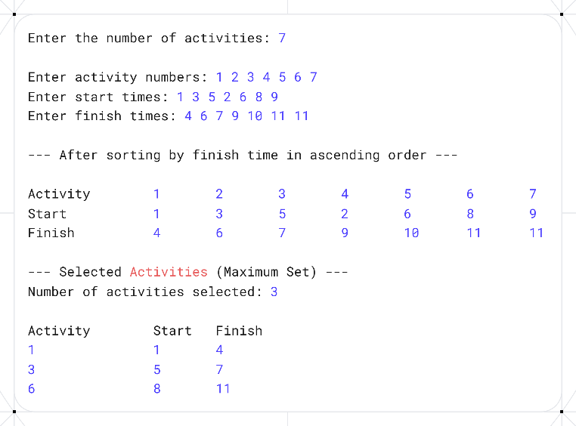

Analysis:
Input:
- Number of activities n = 7
- Activity numbers: [1, 2, 3, 4, 5, 6, 7]
- Start times: [1, 3, 5, 2, 6, 8, 9]
- Finish times: [4, 6, 7, 9, 10, 11, 11]
Step 1: Sort Activities by Finish Time (Ascending)
Pass | Operation | Finish Array (After Pass)
1 | Compare & swap where needed | [4,6,7,9,10,11,11] (already mostly sorted)
After sorting by finish time:
Activity | Start | Finish
1 | 1 | 4
2 | 3 | 6
3 | 5 | 7
4 | 2 | 9
5 | 6 | 10
6 | 8 | 11
7 | 9 | 11
Step 2: Select Activities (Greedy Algorithm)
Initialize:
- Select first activity → Activity 1 (start 1, finish 4)
- lastFinish = 4
- Selected activities: [1]

Iteration over remaining activities:
- Activity 2: start = 3 < lastFinish = 4 → skip
- Activity 3: start = 5 ≥ lastFinish = 4 → select
  - lastFinish = 7
  - Selected: [1, 3]
- Activity 4: start = 2 < lastFinish = 7 → skip
- Activity 5: start = 6 < lastFinish = 7 → skip
- Activity 6: start = 8 ≥ lastFinish = 7 → select
  - lastFinish = 11
  - Selected: [1, 3, 6]
- Activity 7: start = 9 < lastFinish = 11 → skip
Final Output
Selected Activities (Maximum Set):
Activity | Start | Finish
1 | 1 | 4
3 | 5 | 7
6 | 8 | 11
Number of activities selected: 3

Complexity Analysis:
Time Complexity
- Input reading
  - Complexity: O(n)
- Sorting activities by finish time
  - The code uses bubble sort, which compares and swaps elements repeatedly.
  - Bubble sort in the worst case requires O(n²) comparisons and swaps.
  - Each swap also rearranges three arrays (activity, start, finish), but this does not change the overall order of growth.
  - Complexity: O(n²)
- Selecting activities (Greedy loop)
  - After sorting, the algorithm iterates through all n activities once to select the maximum set of non-overlapping activities.
  - Each iteration involves a simple comparison: start[i] ≥ lastFinish.
  - Complexity: O(n)
Space Complexity
- Linear in the number of activities → O(n)

Conclusion:
Both the Fractional Knapsack and Activity Selection problems illustrate the power of greedy algorithms, where making locally optimal choices at each step leads to a globally optimal solution.
Fractional Knapsack:
- By selecting items based on the highest value-to-weight ratio, the algorithm maximizes profit.
- The program handles both full and fractional items, ensuring the maximum possible profit is achieved efficiently.
- Sorting items by ratio is key; it guarantees the greedy choice works.

Activity Selection:
- By always choosing the next activity that finishes earliest, the algorithm selects the maximum number of non-overlapping activities.
- Sorting by finish time ensures that each selection is optimal.
- The algorithm works regardless of the order in which the user inputs activities.

